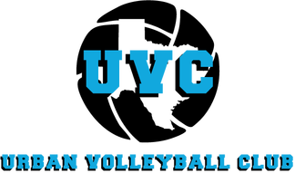
UVC Tryouts

ALL AGES (11U, 12U, 13U, 14U, 15U, 16-18U)
Interested in playing CLUB VOLLEYBALL?
Come out and join us for our tryouts.

July Tryout Times
10U-12U: Sat July 10th at 9am- 10am
13U-14U: Sat July 10th at 10am- 11am
15U-16U-17U-18U: Sat July 10th 11am- 12pm

August Tryout Times
10U-12U: Sat Aug 21st at 9am- 10am
13U-14U: Sat Aug 21st at 10am- 11am
15U-16U-17U-18U: Sat Aug 21st 11am- 12pm

September Tryout Times
10U-12U: Sat Sept 18th at 9am- 10am
13U-14U: Sat Sept 18th at 10am- 11am
15U-16U-17U-18U: Sat Sept 18th 11am- 12pm

Pre-register and pay online for $20
or
$25 Cash only at door
Register here: Urban Volleyball Club 2021-2022 Season Try-Outs (jotform.com)

6267 Friendship Rd. Tolar, TX 76476

For questions or more information contact
Bridgette Matthews Tommy Matthews
254-396-3417 817-578-0387
What to bring to tryouts: Copy of birth certificate
Forms can be found on our website at: www.urbanvolleyballclub.com

